# FREEDOM INTERNATIONAL SCHOOL

### # 33, Sector IV, HSR Layout, Bengaluru, Karnataka 560102

SCHOOL CODE: 45175 AFFILIATION NUMBER:830183

**PHYSICS PROJECT ON**

**UNIVERSAL GATES**

**SUBMITTED BY**

MANNITH NARAYAN

Class XI A

**Under the guidance of**

**Ms. LYDIA SCARIA**

**TGT/PGT- Physics**

**Vice Principal Principal**

**Ms. Clara David Ms. Sneha Rai**

**Freedom International School Freedom International School**

**Bangalore Bangalore**



**FREEDOM INTERNATIONAL SCHOOL**

# 33, Sector IV, HSR Layout, Bengaluru, Karnataka 560102

SCHOOL CODE: 45175 AFFILIATION NUMBER:830183

**CERTIFICATE**

This is to certify that the Physics Project Report entitled

**Simulation of Universal Gates using transistors**

was carried out by MANNITH NARAYAN

of Class **XI A,**

### Roll No. 18 ,

a student of FREEDOM INTERNATIONAL SCHOOL

in partial fulfilment of the Physics Practical Examinations prescribed by the CBSE during the Academic Year 2019-2020.

I certify that this project has been done by him/her with his/her own effort under the guidance of the teacher.

#### Signature of the Teacher in Charge Signature of the Principal

**Mr./Ms. Faculty name Ms. Sneha Rai**

**Name of the Examiners Signature with date**

**1.**

**2.**

**ACKNOWLEDGEMENT**

I would like to express my special thanks and gratitude to my teacher and project guide Ms. Lydia Scaria who gave me this wonderful opportunity to work on this interesting project, which required a lot of research and was an excellent learning experience.

My sincere thanks goes to Ms. Sneha Rai, our Principal, for her coordination in extending every possible support for the completion of this project.

I also extend my sincere thanks to our lab assistant, Ms. Aruna P for her assistance during the project work.

I also thank my parents for their constant motivation and support.

Last but not least, I would like to thank all those who had helped me directly or indirectly towards the completion of this project.

**INDEX**

|  |  |  |
| --- | --- | --- |
| **Sl. No.** | **CONTENT** | **PAGE NO.** |
| 1 | Introduction | 5 |
| 2 | Experiment | 10 |
| 3 | References | 17 |

**INTRODUCTION**

**LOGIC GATES:**

A logic gate is an elementary building block of a digital circuit. It makes “logical decisions” based on the different combinations of digital signals present on its inputs. Digital logic gates may have more than one input but generally only have one digital output. Most logic gates have two inputs and one output.

At any given moment, every terminal is in one of the two binary conditions low (0) or high (1), represented by different voltage levels. The logic state of a terminal can, and generally does, change often, as the circuit processes data. In most logic gates, the low state is approximately zero volts (0 V), while the high state is approximately five volts positive (+5 V).

Individual logic gates can be connected together to form combinational or sequential circuits or larger logic gate functions. Different types of logic gate implement different Boolean function, that is, it performs a logical operation on one or more logic inputs and produces a single logic output. Depending on the context, the term may refer to an ideal logic gate, one that has for instance zero rise time and unlimited fan-out, or it may refer to a non-ideal physical device.

Logic gates are primarily implemented electronically using diodes or transistors, but can also be constructed using electromagnetic relays (relay logic), fluidic logic, pneumatic logic, optics, molecules, or even mechanical elements. With amplification, logic gates can be cascaded in the same way that Boolean functions can be composed, allowing the construction of a physical model of all of Boolean logic, and therefore, all of the algorithms and mathematics that can be described with Boolean logic.

A large number of electronic circuits (in computers, control units, and so on) are made up of logic gates. These process signals represent either true(LOW) or false(HIGH). The most common symbols used to represent logic gates are sh own below.

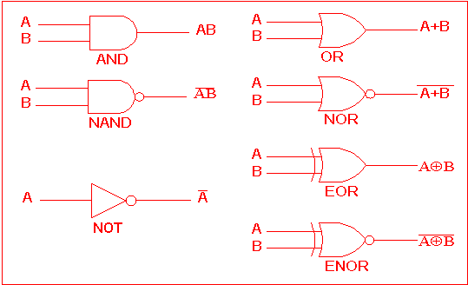

**UNIVERSAL LOGIC GATES:**

The repeated use of the OR, the AND or the NOT gates alone cannot give a different gate. But the repeated use of the NAND or the NOR gates alone can give all basic gates like OR, AND and NOT gate. Hence the **NAND** and the **NOR** gates are also called Universal Logic Gates. In digital circuits, these gates serve as digital building blocks.

**NAND GATE**

In digital electronics, a NAND gate (negative-AND) is a logic gate which produces an output that is false only if all its inputs are true; thus its output is complement to that of the AND gate. A LOW (0) output results only if both the inputs to the gate are HIGH (1); if one or both inputs are LOW (0), a HIGH (1) output results. It is made using transistors. By De Morgan's theorem, AB=A+B, a NAND gate is equivalent to inverters followed by an OR gate. The NAND gate is significant because any Boolean function can be implemented by using a combination of NAND gates. This property is called functional completeness.

We will start with a 2 input NAND gate. The symbol for a 2 input NAND gate is as follows.

A

B

Q

The truth table for the 2 input NAND gate is shown below.

|  |  |  |
| --- | --- | --- |
| Inputs | | Output |
| B | A | Q |
| 0 | 0 | 1 |
| 0 | 1 | 1 |
| 1 | 0 | 1 |
| 1 | 1 | 0 |

The Boolean expression for a 2 input NAND gate is



**NOR GATE**

The NOR gate is a digital logic gate which behaves according to the truth table. A HIGH output (1) results if both the inputs to the gate are LOW (0); if one or both input is HIGH (1), a LOW output (0) results. NOR is the result of the negation of the OR operator. It can also be seen as an AND gate with all the inputs inverted. NOR is a functionally complete operation—NOR gates can be combined to generate any other logical function. By contrast, the OR operator is monotonic as it can only change LOW to HIGH but not vice versa.

We will start with a 2 input NOR gate. The symbol for a 2 input NOR gate is as follows

A

B

Q

The truth table for the 2 input NOR gate is shown below.

|  |  |  |
| --- | --- | --- |
| Inputs | | Output |
| B | A | Q |
| 0 | 0 | 1 |
| 0 | 1 | 0 |
| 1 | 0 | 0 |
| 1 | 1 | 0 |

The Boolean expression for a 2 input NOR gate is



**TRANSISTORS**

A Transistor is a semiconductor device used to amplify or switch electronic signals and electric power. It is composed of semiconductor material usually with at least three terminals for connection to an external circuit. A voltage or current applied to one pair of the transistor's terminals controls the current through another pair of terminals. Because the controlled (output) power can be higher than the controlling (input) power, a transistor can amplify a signal.

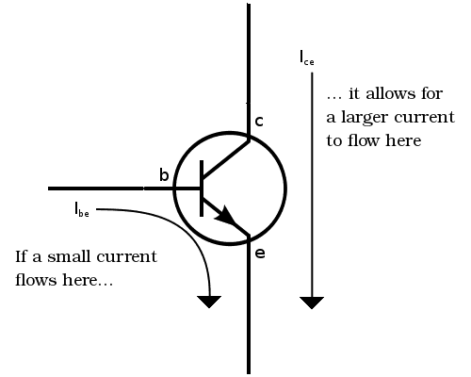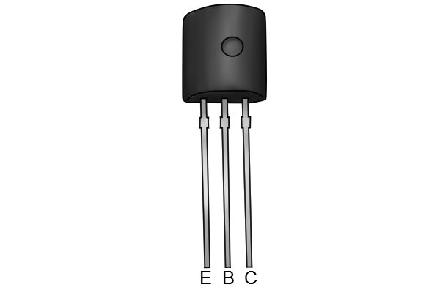

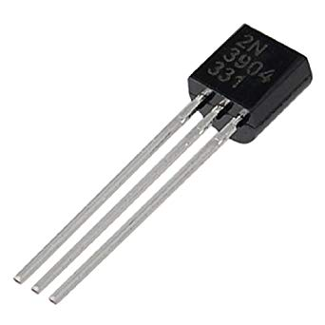

**EXPERIMENT**

**AIM:** To construct and stimulate universal gates using

Transistors.

**MATERIALS REQUIRED:**

1. Batteries
2. Breadboard
3. 2 NPN transistors
4. LED
5. 3 kΩ ¼ W resistor
6. 2 Normally open Push buttons
7. Jumper wires

**THEORY:**

**NAND GATE:**

The output of a NAND gate is LOW if both inputs are HIGH, otherwise, the output is HIGH.

The inputs to the gate are controlled by the pushbutton switches. When a switch is open, the corresponding input is LOW. When the switch is depressed, the corresponding input is HIGH.

The output from this gate is sent through an LED, so the LED is on when the output is HIGH and off when the output is LOW.

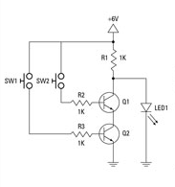

**NOR GATE:**

The output of a NOR gate is HIGH if both inputs are LOW. Otherwise the output is LOW.

The inputs to this gate are controlled by normally open pushbutton switches. When a switch is open, the corresponding input is LOW. When the switch is depressed, the corresponding input is HIGH.

The output from this gate is sent through an LED, so the LED is on when the output is HIGH and off when the output is LOW.

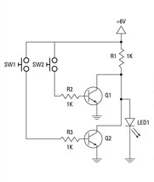

**PROCEDURE:**

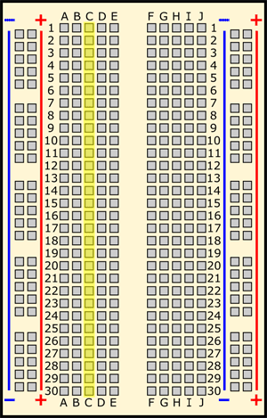**NAND GATE:**

1. Insert transistors Q1 and Q2.

Lead Q1 Q2

Collector: G9 G13

Base: G10 G14

Emitter: G11 G15

1. Insert resistors R1, R2 and R3.

R1- F9 to positive bus

R2- F10 to C10

R3- F14 to C14

1. Insert the LED in the breadboard

The cathode (short lead) is inserted at the ground bus and anode (long lead) is inserted at J9.

1. Insert the jumper wires.

Jumper 1 is inserted from H11 to H13.

Jumper 2 is inserted from J15 to ground bus.

1. Insert switches SW1 and SW2.

SW1 is inserted from A10 to positive bus.

SW2 is inserted from A14 to positive bus

1. Connect the batteries at the positive and negative buses.
2. Test the 4 combinations (HH, HL, LH, LL) using the open pushbuttons. Pushbuttons are used for the two inputs. The LED will be on until you press both of the pushbuttons. This action causes both inputs to go HIGH, which causes the output to go LOW and the LED to go dark.

1. Note the observations in the observation table.

**NOR GATE:**

1. Insert transistors Q1 and Q2.

Lead Q1 Q2

Collector: G9 G13

Base: G10 G14

Emitter: G11 G15

1. Insert resistors R1, R2 and R3.

R1- F9 to positive bus

R2- F10 to C10

R3- F14 to C14

1. Insert the LED in the breadboard

The cathode (short lead) is inserted at the ground bus and anode (long lead) is inserted at J9.

1. Insert the jumper wires.

Jumper 1 is inserted from J10 to ground bus.

Jumper 2 is inserted from J15 to ground bus.

Jumper 3 is inserted from I9 to I13.

1. Insert switches SW1 and SW2.

SW1 is inserted from A10 to positive bus.

SW2 is inserted from A14 to positive bus

1. Connect the batteries at the positive and negative buses.
2. Test the 4 combinations (HH, HL, LH, LL) using the open pushbuttons. Pushbuttons are used for the two inputs. The LED will be on until you press both of the pushbuttons. This action causes both inputs to go HIGH, which causes the output to go LOW and the LED to go dark.

1. Note the observations in the observation table.

**OBSERVATION:**

**NAND GATE**

|  |  |  |
| --- | --- | --- |
| Inputs | | Output |
| B | A | Q |
| 0 | 0 |  |
| 0 | 1 |  |
| 1 | 0 |  |
| 1 | 1 |  |

**NOR GATE**

|  |  |  |
| --- | --- | --- |
| Inputs | | Output |
| B | A | Q |
| 0 | 0 |  |
| 0 | 1 |  |
| 1 | 0 |  |
| 1 | 1 |  |

**RESULT:**

NAND gate is a logic gate which produces an output which is false only if all its inputs are true. Thus NAND gate is a complement to that of an AND gate.

NOR gate is a logic gate which produces an output which is true when all of its inputs are false. Thus NOR gate is a complement to that of an OR gate.

**PRECAUTIONS:**

1. All connections should be neat, clean and tight
2. The jumper wires should be as short as possible to avoid tangling of wires
3. Avoid interchanging the circuit

**SOURCES OF ERROR:**

1. The transmitter or LED can be faulty
2. Personal error

**REFERENCES**

The following websites were used as a guide for compiling the project

1. Dummies
2. Quora